**Task 1:**

**Using the Query 2 you created change the points to reads times by 10 and plus 100. Record your results in your word document**

SELECT last_name, first_name, points *10, points +100

FROM customers

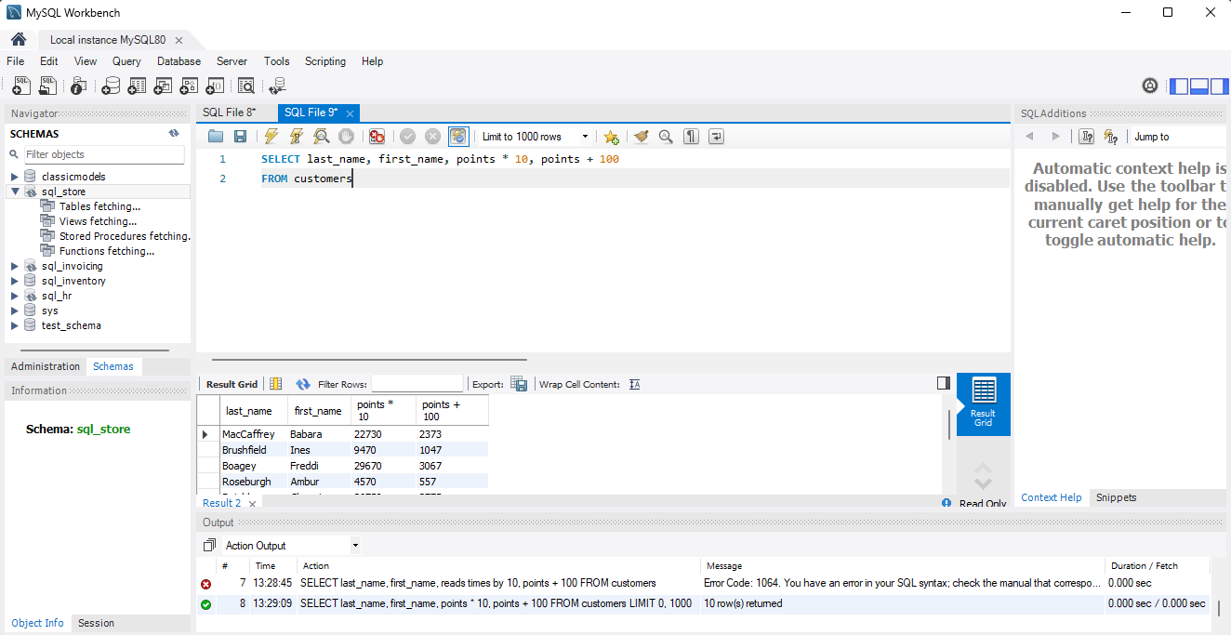

**Task 2:**

**In this task create a new query to find all the customers with a birth date of > '1990-01-01'**

select *

from customers

WHERE birth_date > '1990-01-01'

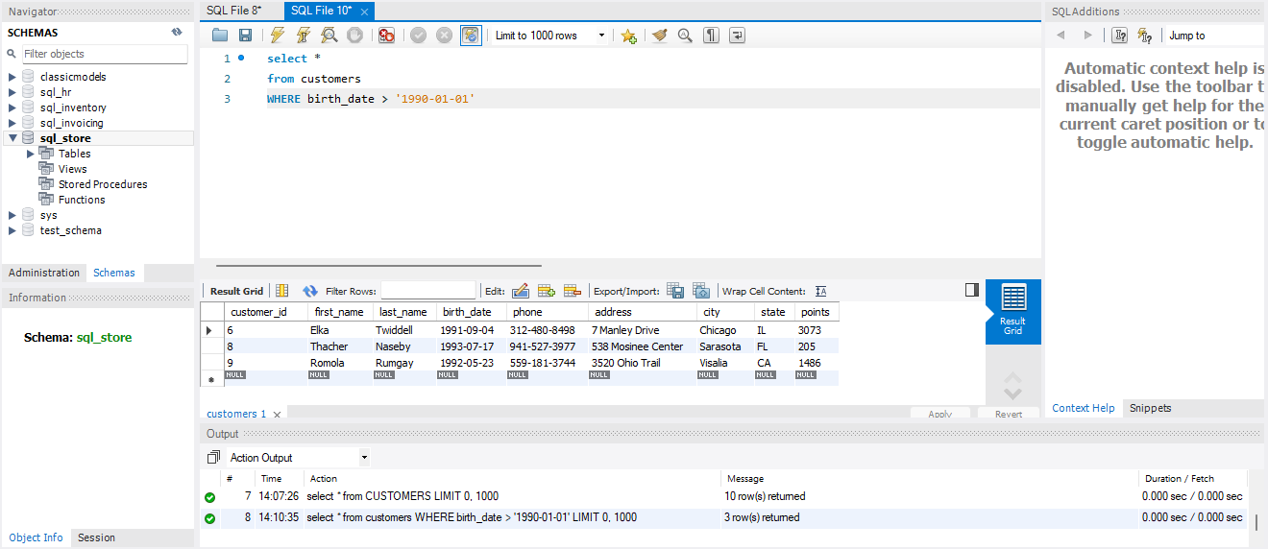

**Task 3:**

**Select sql_inventory.**

**Write a query to find out the name of the product with most amount in stock.**

SELECT name, quantity_in_stock

FROM products

ORDER BY quantity_in_stock DESC

LIMIT 1;

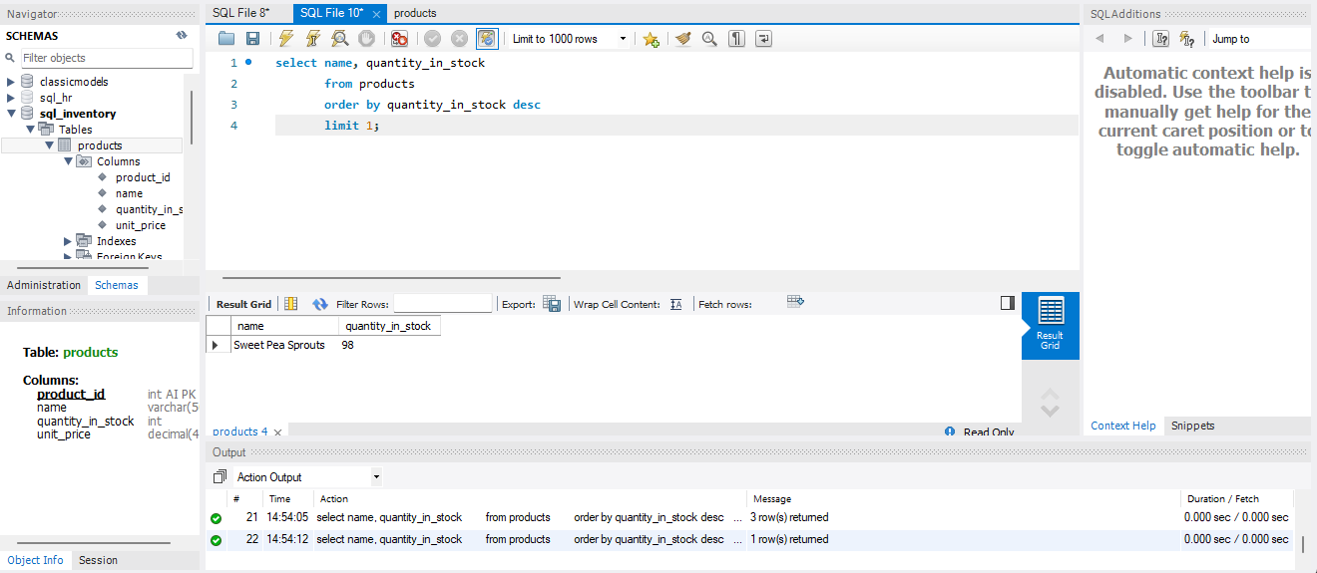

**Task 4:**

**Select sql_inventory.**

**Write a query to find out the name of the most expensive product.**

SELECT MAX(unit_price) AS Most_Expensive_Products, name

FROM products

GROUP BY name

ORDER BY Most_Expensive_Products DESC

LIMIT 1;

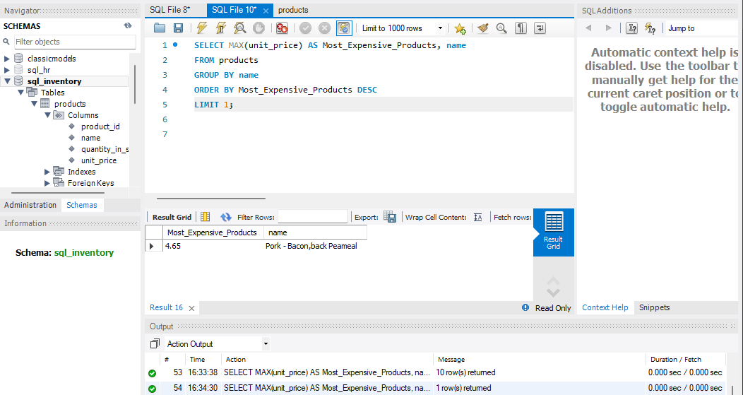

**Task 5:**

**Select sql_store.**

**Write a query to find out the first name, last name, address and the birthdate of the oldest customer.**

SELECT first_name, last_name, address, MAX(birth_date) AS birth_date

FROM customers

GROUP BY first_name, last_name, address

ORDER BY birth_date ASC

LIMIT 1;

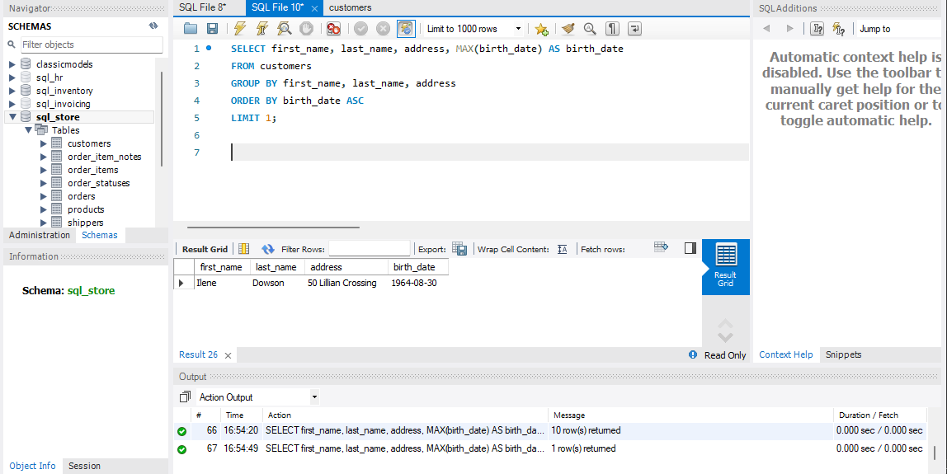

**EER Diagram:**

